**How to embed Power Automate in Dynamics 365 for Finance and Supply Chain**

Model-driven app design is a component-focused approach to app development for Dynamics 365. In this topic, you simplify how to create an App for Finance and Supply chain solution

**Step 1: Adding Finance application in our environment**

1. Go To <https://trials.dynamics.com/> (we are using trial module for our session)

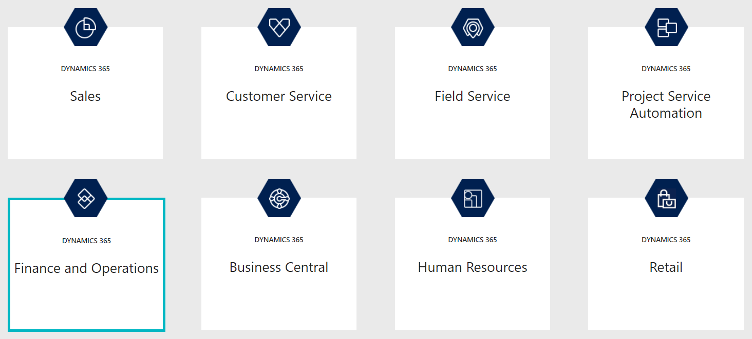

1. Select Finance and Operations
2. Enter Work Email, i.e. same email we created for office 365 developer subscription
3. Enter 10-digit Phone number

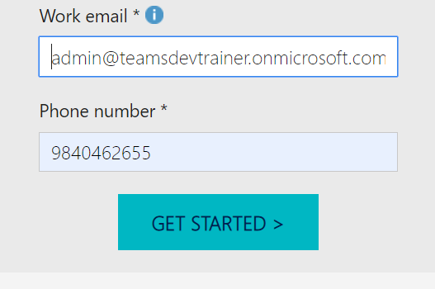

1. Click Get Started button, it will redirect to new window

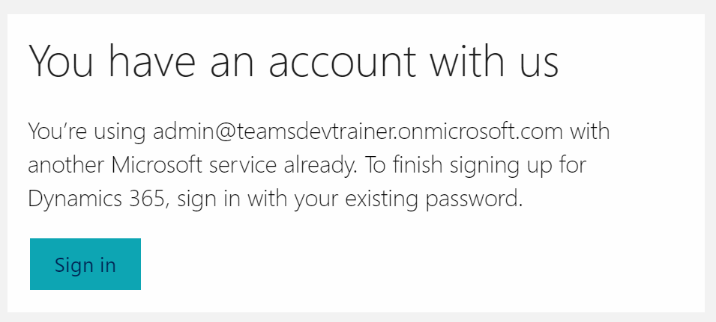

1. Sign In and continue
2. It will open the dynamics 365 Finance and Operations Business Application dashboard

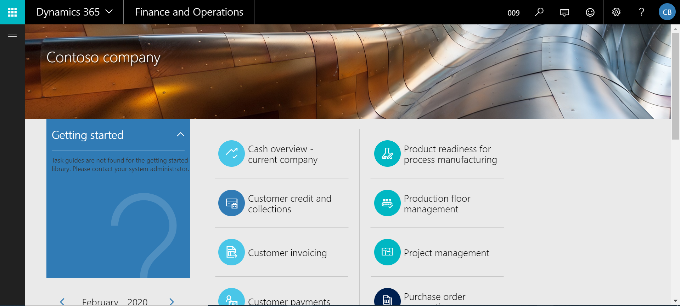

**Step 2: Create a flow by using Dynamics 365**

By using a Dynamics 365 connector, you can create flows that initiate when an event occurs in Dynamics 365, or some other service, which then performs an action in Dynamics 365, or some other service.

In Power Automate, you can set up automated workflows between your favourite apps and services to synchronize files, get notifications, collect data, and more.

## **Create a task from a lead**

If a template isn’t available for what you need, create a flow from scratch. This walkthrough shows you how to create a task in Dynamics 365 whenever a lead is created in Dynamics 365

1. Sign in to the [Power Automate website](https://flow.microsoft.com/).
2. Click or tap **My flows**, and then click **New 🡪 Automated -** **from blank**.
3. In the list of flow triggers, click or tap **Dynamics 365 - When a record is created**.
4. If prompted, sign into Dynamics 365.
5. Under **Organization Name**, select the Dynamics 365 instance where you want the flow to listen.
6. Under **Entity Name**, select the entity that you want to listen to, which will act as a trigger initiating the flow.
7. For this walkthrough, select **Accounts**.
8. Click Next Step
9. Select the action 🡪 Send an email
10. Enter To, Subject and Body

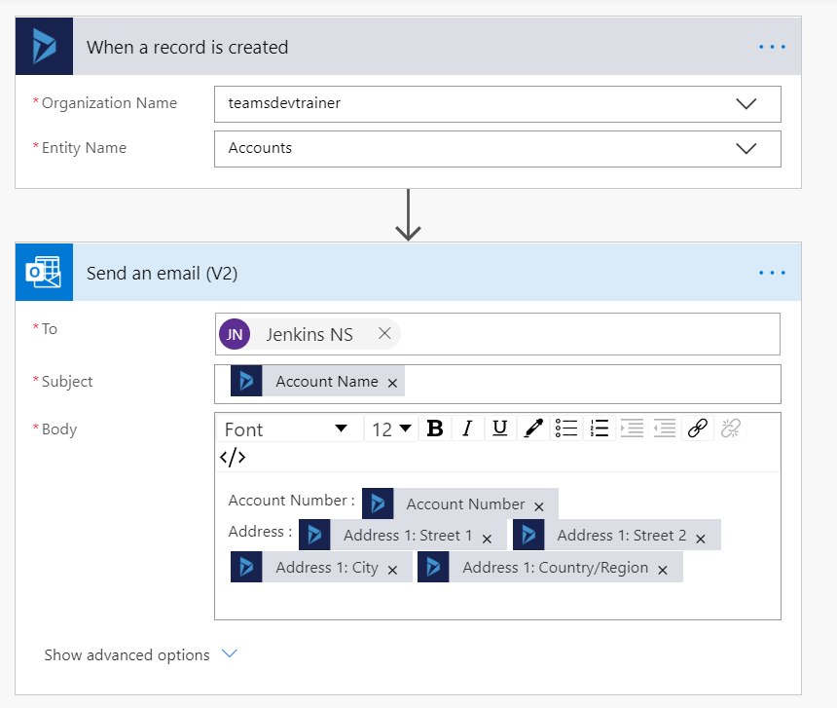

1. Save to **Create flow**
2. Test the flow
   * Add new record in Dynamics 365 Account Entity
   * It will send an email to you

